OOP LAB NO.1 TASKS
Task No. 1: Write a program that prints a mosque, similar to the following:
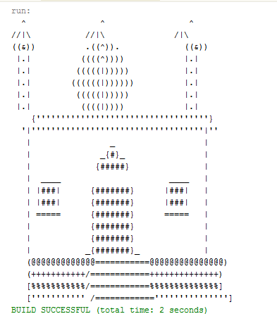

Task No. 2: Write a JAVA program, which receives the input of two integer numbers, operation (+,-
,*,/,%, power, square-root and factorial) and compute arthematic operations. Generate a menu for operations and ask user after every operation if they want to do another. (Hint use switch case)
Task No. 3: Make a program in JAVA in which take no. of items, price of items and name of items as input from the user and give the discount according to the following conditions:
- If from Bahria University give discount of 30%.
- Else if the total amount is greater then 50,000 and less than 100,000 give discount of 20%.
- Else if the total amount is greater then 100,000 give discount of 30%.

Task No. 4: Write a JAVA program which will implement the following formulae using methids.
- Automobile Tire Pressure: P = 0.37m(T + 460)/V P = pressure in psi.
V = volume in cubic feet
m = mass of air in pounds
T = temperature in Fahrenheit

- Pulley formulas
  - calculate the speed of one pulley if there are 2 pulleys connected with a belt:
RPM2 = diameter1/diameter2 * RPM1

  - calculate the amount of weight that can be lifted with a multiple pulley system:
weight lifted = force exerted * number of up ropes

- The body mass index (BMI), is a heuristic proxy for human body fat based on an individual's weight and height. BMI does not actually measure the percentage of body fat. We will be building a BMI calculator method. Body mass index (BMI) is computed using the the formula,

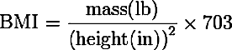
Where mass is the subject's weight in pounds (lb) and height is the height in inches (in). The value 703 is a factor to convert BMI to a value that matches the original BMI calculations done in metric units (i.e. kilograms-meters).

